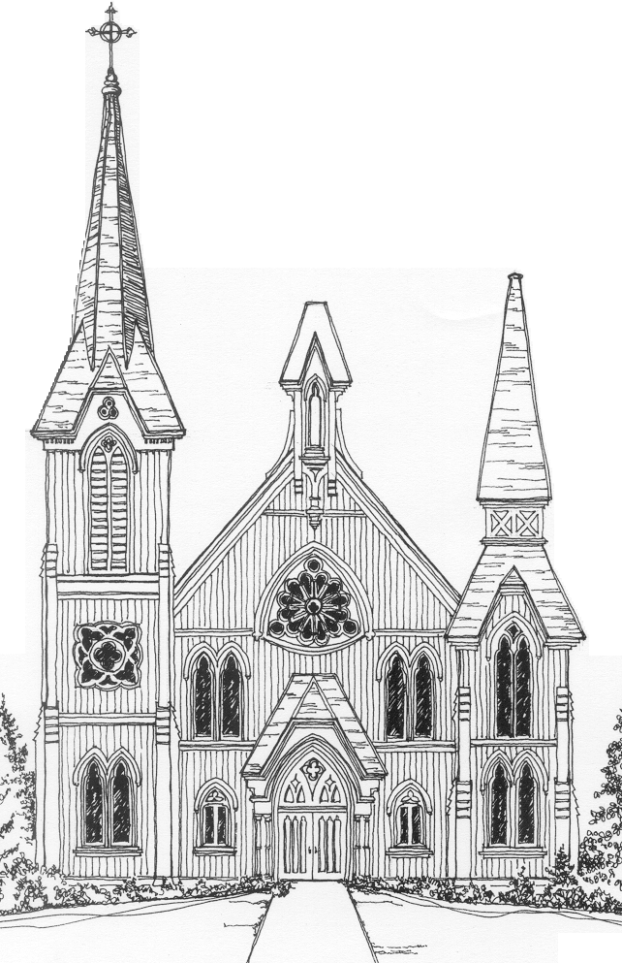
BEDFORD PRESBYTERIAN CHURCH

Service for the Lord’s Day
February 9, 2020

THE GATHERING

PRELUDE – Liebster Jesu J. S. Bach

CHIMING OF THE HOUR

INTROIT – They That Do the Will of God G. Thalben-Ball

WELCOME

*CALL TO WORSHIP - Psalm 95:1-2

Leader: O come, let us sing to the Lord and shout with joy to the rock
of our salvation!
People: Let us come into God’s presence with thanksgiving, singing
joyful songs of praise!

*HYMN 466 – O for a Thousand Tongues to Sing

PRAYER OF CONFESSION

Sometimes, O God, we forget people, or we toss them aside – the difficult ones, the needy ones, the ones that are hard to spend time with, the ones who confront us. And sometimes when we do things like that, it’s not really about the other people, but about us. We are uncomfortable, or we feel guilty, or we follow brighter, shinier people, or we worry about what will make us look good. We are in such desperate need of your forgiveness. We need to be forgiven distorted priorities, for our mistakes, for confusing what the world values with what you value. Help us to live more faithfully, to see more clearly, and to love more deeply. In Christ we pray. Amen.**

*ASSURANCE OF PARDON
Leader: The mercy of the Lord is from everlasting to everlasting!
People: In Jesus Christ, God calls us by name, claims us in love,
and brings us hope!

*ASCRIPTION OF PRAISE - Hymn 599

Jesus, remember me
when you come into your kingdom.
Jesus, remember me
when you come in to your kingdom. (Sung 2x)

*PASSING OF PEACE

Leader: The peace of Christ be with you.
People: And also with you.

TIME WITH THE CHILDREN and CHILDREN’S OFFERING
This year’s children’s offering is designated to Heifer Project and Laundry Love. Children should come forward for the Time with the Children
with their offering. Adults who wish to contribute to the children’s
offering will have an opportunity during the Anthem following
the Time with the Children.

LORD’S PRAYER
Our Father*, who art in heaven, hallowed be thy name. Thy kingdom
come, thy will be done, on earth as it is in heaven. Give us this day
our daily bread; and forgive us our sins, as we forgive those who
sin against us; and lead us not into temptation, but deliver us from
evil. For thine is the kingdom and the power and the glory, forever.

ANTHEM – A Gaelic Blessing John Rutter

THE PROCLAMATION

SCRIPTURE READING – 26:36-46

SERMON – Was Jesus’ Middle Name Really Bubba? J. Patrick Vaughn

*HYMN 403 – What a Friend We Have in Jesus

THE SENDING

MOMENT for MINISTRY Sarah Ryan – ESP

PRESENTATION OF TITHES AND OFFERINGS

OFFERTORY – Lord, Make Me an Instrument of Your Peace Peter Aston

*DOXOLOGY

Praise God from whom all blessings flow.
Praise him all creatures here below.
Praise him above ye heavenly host.
Praise Father, Son and Holy Ghost. Amen.
- or –
Praise God from whom all blessings flow. Praise God all creatures here below. Praise God above ye heavenly host. Creator, Christ, and Holy Ghost. Amen.

THE PRAYER OF THANKSGIVING
*HYMN 358 – Help Us Accept Each Other

*BENEDICTION

BENEDICTION RESPONSE – Threefold Amen R. Hanson

POSTLUDE – Praeludium in C J. S. Bach
*Please stand if you are comfortable doing so.

**adapted from Beth Merrill Neel

Announcements for the Week of
February 9th – February 15th

In-Touch Ministry
Did you know that there are some members of our church who are confined to their homes and are unable to attend services on Sunday? At
Second Sunday Soup on February 9th we will have a table set up with some blank cards so that attending members can communicate their thoughts to those who cannot be with us.
The names of some of our members who are unable to get out and socialize will be available along with cards for you to write your thoughts and news. The cards will then be mailed out over time.
If you have any cards you would like to donate, please bring them in.

2019 Annual Meeting

The Annual Meeting of the Congregation will be held TODAY in
Fellowship Hall following the worship service. The congregation is
invited to gather for soup and fellowship at that time.
Did you know?
A key feature of Presbyterian governance is elected representation. Yet, ruling elders do NOT represent any particular constituency (e.g., women, youth, older couples etc...). Instead, the session seeks to work together to discern how the church might live and serve faithfully.

Sunday Flowers
Our beautiful flowers today are brought to you today by
Alan & Joan McDougall
In loving memory of her parents, Sadie and Bobby Woods.

2020 Children's Bible Study

Bedford Presbyterian Church will be offering an
Introduction to the Bible class this spring and
Matt Valenti will be the instructor.

The class will be 8 lessons, scheduled from Mid-March through May, with the exact dates being solidified in coming weeks.
Lessons will be on Sunday mornings during worship following the
Time with Children (participants will be in the Bible Study class
instead of Sunday Spirit).

Children in 3rd grade or higher are welcome to enroll, with
the expectation being that participants will attend each class.

At the end of the class, participants will receive their own Bible.

If you would like to enroll your child or have any questions, please contact
Matt Valenti: matt_valenti@yahoo.com

Winter Midnight Run

Thank you to everyone who has signed up so far for Midnight Run supplies.
We are continuing to add items each week, and this week we are collecting men’s and women’s underwear and socks.

Please bring these items to the church and place in the box by the building’s entrance closest to the Chapel stairs by March 25th.

Please click the following link to sign up for items on the sign up genius.

https://www.signupgenius.com/go/9040D44A4A823A2FB6-midnight
The above link was listed on our latest E-NEWS, where you will be
able to just ‘click’ on the link.

BPC is hosting the ESP from March 2nd – March 8th.
We need volunteers for the following:

1. Prepare & serve dinner for approximately 20 people. This involves preparing a simple meal, such as a stew, a chicken casserole or lasagna. We’ll give you more detailed suggestions once you sign up. Typically, you will arrive at the church at 9 PM and you will be done shortly after 10PM. It’s best if there are two or three of you to help serve.
2. Prepare breakfast bags. Breakfast items such as bagels, muffins, hard boiled eggs, fruit and a juice have to be bagged and brought to the church the evening before.
3. Stay overnight in the Church. The ESP has a paid staff member who sleeps in Fellowship Hall with the group. In addition, we like a member of our congregation to spend the night, in a separate space, to be available in case of an emergency. We have never had an emergency situation, but we do need a church member to stay over. You can leave as early as 6:00 AM the next morning.
4. Our guests have a shower at the Church during the week. Donations of soap and shampoo will be welcome. Please drop it off in the designated container outside the Church office.

Please contact Shirani at shiranip@gmail.com, telephone 845-797-6435 or Jessica at the Church Office, 234-3672. A signup sheet will also be available in Fellowship Hall following Sunday services. We really appreciate your help with this wonderful program which provides shelter for homeless men and women in Northern Westchester.

Large Fireproof Safe & Lateral File Cabinet Needed

The church is interested in acquiring a large fireproof safe to use for the safekeeping of valuables, important old archived documents, etc. Before we begin a search to purchase one, we are asking whether you or someone you may know has such a safe in their possession that is in good condition and is in working order that they would like to donate.

We are also in need of a lateral file cabinet.

If either is available, please contact Jessica in the church office.
(914) 234-3672 x1001

Thank you
Toys for our Little Ones

There are now two baskets (one at the front of the church and one at the back), that contain crayons, paper and a few toys and books. These baskets are available for families to take advantage of during worship.
If anyone has appropriate little books or things that would be useful, and you are no longer using them, please feel free to add them to the baskets.

Second Sunday Soup
A great big thank you to
Brian Hiller-Dupont, Barbara Kanner & Angeliki Nevrodis
for sponsoring today’s Second Sunday Soup.

2020 Directory Update
We continue the process of collecting information for the
2020 Church Directory,
as well as updating our current database.
Forms are available at the front and back of the sanctuary and will be available at Coffee Hour as well. For your convenience, you can also submit your information directly to the BPC office via a link on our website. Go the BPC homepage and click on Update Member Directory.

Please take the time to fill out a form or send in your information via our web site. It is the only way for us to have updated information for you and your family. Emails are really important for getting out church news that you may not hear about if you miss worship. Our hope is to include photos as well, but more information on that will be upcoming.

PLEASE PRINT YOUR INFORMATION FOR CLARITY

Laundry Love
﻿ Laundry Love is always happy to recruit new volunteers and shifts are easy-breezy, just 1.5 hours per month. Choose from 5-6:30pm or 6:30-8pm; mix and match, or take both, if you'd like! Signing up in advance helps everyone anticipate coverage. Fill in the form in Fellowship Hall on Sundays or contact Elizabeth Messinger by phone 914-980-0059 or email LaundryLoveMtKiscoNY@gmail.com.
Join in and wash on!

Flowers for the Sanctuary
Flowers bring beauty to our Sunday morning service and can also be a memorable way to celebrate a special day or a special person in your life. Donating flowers couldn’t be easier! Simply contribute $50 to the church flower fund and create your own dedication line to run in the Sunday bulletin. Then, after worship, you or the person you’re celebrating can take the flowers home!
If you are interested, please contact:
Michele Eames at mdeames@optimum.net or 914-715-3223 with any questions. There will also be a sign-up sheet in
Fellowship Hall following worship services.

Contributions & Donations

We are so grateful for our support of our wonderful church.
Please clearly mark you checks so that we can apply your contributions/donations to the correct account:
Flowers, Pledges, etc.

Spirituality and Practice Groups at BPC!

In addition to all the wonderful doings at Bedford Presbyterian Church, there are also opportunities to simply BE! The Spirituality and Practice groups, which meet on the third Tuesday evening (7-8:30pm) and the third Wednesday morning (9:30-11am) of each month, offer a change of pace, so necessary to the care and well-being of our souls.

Each month, we explore a different spiritual practice. For example, in the past we have explored the “practices” of Civility, Resilience, Doubt, Risk, Poetry, Islam, Truth, Play, Making Holy, Prayer, and Listening: not just what we think about them, or how they dovetail with our theology, but how we can actually live them. What does it mean to practice, anyway? The last thing we all need is one more thing on our “to- do” list, so how can we think about and inhabit the practices that nurture our life of faith? Worship, of course, is a key aspect of a faith journey, and so is service, things in which BPC members are so adept.

But there is also the wider arena of our spiritual lives that need tending to in the everyday. This is what we explore. The groups meet for an hour and a half, with discussion, reading, visual arts, sometimes writing (and sometimes wandering!) and end with a guided meditation to ground ourselves fully into our bodies and the present, peace-full moment.
﻿
Both relaxing and invigorating.

Led by Rev. Leslie Mott- if you have any questions, please feel free to email her at: revleslie@optonline.net.

Events for the Week

Today, February 9
10:00 AM Worship (Sanctuary) Rev. J. Patrick Vaughn
11:00 AM Second Sunday Soup (Fellowship Hall)
11:30 AM Annual Meeting (Fellowship Hall)

Tuesday, February 11
9:30 AM Senior Group Exercise (Fellowship Hall)
10:30 AM Adult Bible Study (Conference Room)
7:15 PM AA Men & Women (Fellowship Hall)

Thursday, February 13
9:30 AM Senior Group Exercise (Fellowship Hall)
7:15 PM AA Men & Women (Fellowship Hall)
7:30 PM Choir Practice (Sanctuary)

Friday, February 14
9:00 AM Yoga (Chapel)
6:45 PM AA Women (Chapel)

Saturday, February 15
7:15 PM AA Men & Women (Fellowship Hall)

The Rev. Dr. J. Patrick Vaughn, Interim Pastor
The Rev. Heather Brown-Huston, Minister for Congregational Life
John Lettieri, Director of Music
Elyssa Michaels, Director of High School & Middle School Youth Groups
The Rev. Leslie Mott, Coordinator for Spirituality and Practice
Sunday Worship Service 10:00 AM
Church School & Childcare 10:00 AM

Email: Office@bedfordpreschurch.org www.bedfordpreschurch.org
44 Village Green Bedford, NY 914-234-3672

Office Hours:
Monday – Friday 9 am – 3 pm
NYS Notary Public available during Office Hours

